EXP NO:12 | MONGODB CONNECTIVITY USING JDBC
Date: | MONGODB CONNECTIVITY USING JDBC

Objective:
To perform mongodb connectivity using jdbc.
Procedure:
Step1: Download and include the MongoDB JDBC/Java driver.
Step2: Create a new Java project and import the MongoDB driver JAR into your build path.
Step3: Use MongoClient or MongoClients to establish a connection to the MongoDB server.
Step4: Select the database and collection you want to work with using getDatabase("yourDB") and getCollection.
Step5: Perform operations like insert, update, delete, or read documents using the Java API. Step6: Close the MongoDB connection with close() to release resources.
Java Class:
import com.mongodb.client.MongoClient;
import com.mongodb.client.MongoClients;
import com.mongodb.client.MongoDatabase;
import com.mongodb.client.MongoCollection;
import org.bson.Document;
public class Main { public static void main(String[] args) {
MongoClient client = MongoClients.create("mongodb://localhost:27017"); MongoDatabasedb = client.getDatabase("StudentsDB");
MongoCollection collection = db.getCollection("students");
Document doc = new Document("name", "Parmila") .append("age", 19); collection.insertOne(doc); System.out.println("Data Inserted"); client.close();
}}

Query: use studentsDB
db.students.find()
Output:
- IntelliJ window screenshot:
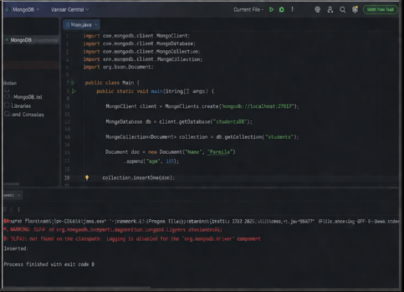
2.Terminal command input screenshot:
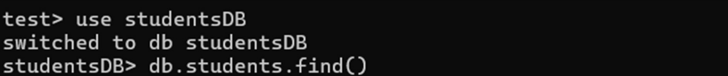

- Terminal command output screenshot:
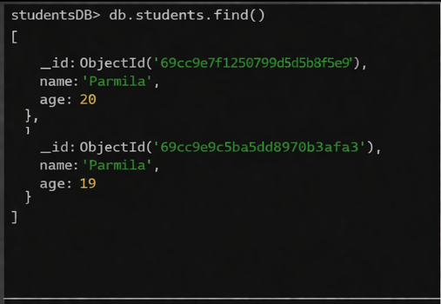
- Manipulating the DB from IntelliJ terminal:
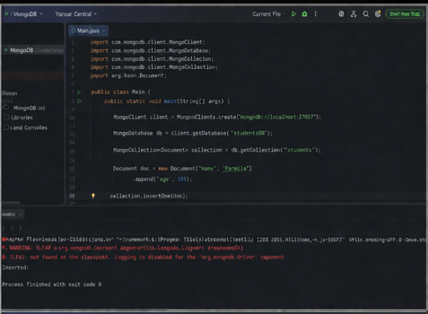

- Verifying changes in MongoDB:

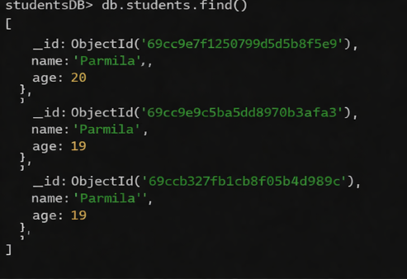

Result:
Thus, the query for MongoDB connectivity using JDBC was executed successfully and the output was verified.

